

PROJECT: E-Logbook Mobile Application with AI-Assisted Writing and
Reminder System for Internship Students

MUHAMMAD HAZIQ AIMAN BIN BAHARI

FYP research proposal submitted in fulfilment of the requirements for Bachelor Of Computer Science (Hons.) Netcentric Computing

Table of Contents
CHAPTER 1 INTRODUCTION 3
1.1 Background of Study 3
1.2 Problem Statement 4
1.3 Objectives 5
1.4 Project Scope 5
1.5 Project Significance 6
CHAPTER 2 Literature Riview 8
2.1 Internship Management and E-Logbook Systems 8
2.2 Information Systems for Internship Management 10
2.3 Artificial Intelligence and Smart Technologies 13
2.4 Development Tools and Technologies 16
2.5 Related Works and Similar Applications 18
CHAPTER 3 Methodology 3
3.1 Project Framework (Software Development Methodology) 3
3.2 Phase 1: Requirement Analysis 6
3.3 Phase 2: System Design 7
3.4 Phase 3: Implementation 11
3.5 Phase 4: Testing 12
REFERENCE 14

INTRODUCTION

Background of Study
An internship, industrial training or practical work is crucial when it comes to obtaining higher education, as it allows students to acquire hands-on experience and make use of theoretical knowledge in practical settings. The students are expected to fill their logbooks during their time in practice as a requirement of the program. Such a system allows tracking the progress of the students and evaluating their performance both by academic and company supervisors to enhance the process in general (Rahman et al., 2024).
Conventional ways of keeping internships' logbooks have certain disadvantages. Namely, students might not keep their books updated due to the lack of motivation. Also, a conventional logbook does not allow real-time supervision, hence, lecturers and company supervisors do not know how well the students are doing and whether there is anything to correct (Dewi & Hanifah, 2024).
In light of the advancements made in the field of mobile technologies and digital platforms, the manual system has become more efficient. The modern systems used in internship management incorporate applications that operate on mobile devices along with algorithms that track progress. In this manner, learners are able to check in and out based on GPS locators. This helps them record time accurately each day (Castro, 2024). Moreover, the introduction of cloud computing in these systems allows for effective handling of large amounts of internship data within univer sity education sectors (Thammastitkul, 2022).
Furthermore, the incorporation of smart digital technology improves the internships carried out by learners through the provision of better tracking and professional development programs. These state-of-the-art systems help connect learners with employers as they develop their skills. They assist learners in improving the quality of their documentation and help teachers manage the process efficiently (Ahmed et al., 2026).
Therefore, this project proposes the development of a mobile-based E-Logbook application integrated with intelligent tracking features. The system will help students keep track of their internship activities through digital logging, submit evidence of work, and get assisted writing tips for improving the quality of entries. Furthermore, there will be reminder notifications to ensure that students do not forget about logging activities. The system also offers interaction capabilities to help students connect with lecturers and supervisors in companies.

Problem Statement
Hence, there arises a need for a better and smarter solution in the form of networks to make the process of recording and monitoring internship activities much better. There have been several changes in the management of internship log books from using old-fashioned pen-and-paper based logging systems to using basic digital log books. Old ways used to include the manual recording of activities by students on physical log books which demanded high levels of discipline and good writing skills. Though the introduction of digital log books aimed at increasing convenience, most systems fail to track and monitor effectively (Rahman, 2022).
One of the greatest problems faced when it comes to internship log book management is the inconsistency of students' entries. Students take too long before updating their log books, making the information recorded less accurate. Moreover, manual recording may result in disorganized and non-professional entries. Despite the introduction of basic digital log books, they do not motivate students to be consistent in their entries (Dewi & Hanifah, 2024).
Another significant problem is the lack of real-time monitoring and centralized access. In traditional systems, supervisors cannot efficiently track student progress because data is not hosted on a unified platform. Physical logbooks are also vulnerable to loss, while basic digital files lack proper synchronization. This limits the ability of academic and company supervisors to evaluate performance effectively and provide timely feedback (Thammastitkul, 2022). Furthermore, without specific algorithms to monitor progress, the coordination between students and supervisors remains inefficient (Castro, 2024).
Moreover, the current system does not have intelligent support and automation technology. This makes it hard for the students to independently verify the quality of their input, especially for those with little writing skills. In addition, the supervisor will be required to manage huge amounts of student data manually, making it cumbersome and ineffective. Therefore, there is a need to come up with an electronic system that emphasizes the improvement of the student’s experience (Ahmed et al., 2026).
Therefore, there is a need for a more efficient, intelligent and centralized solution to improve internship logbook management. This project proposes the development of a mobile-based E-Logbook application integrated with AI-assisted writing, image-based documentation support and reminder notifications. The proposed system aims to enhance student engagement in reflective writing while supporting lecturers and supervisors in monitoring and evaluating activities through a unified digital platform.

Objectives
To develop a web-based E-Logbook mobile application with AI-assisted writing and reminder features to enhance internship record management.
- To identify the current problems and limitations in manual internship logbook management, including issues related to data recording, monitoring, communication and document submission.
- To develop an AI-powered mobile e-logbook system with automation, access control and collaboration features.
- To test and evaluate the effectiveness of the proposed system in improving logbook management, user experience, monitoring efficiency and overall internship performance tracking

Project Scope
The aim of this research is to develop an Internship E-Logbook System using two platforms which is a mobile application and a web-based platform. It is developed for use by administrators, lecturers, and company supervisors for management and supervision of internship activities. Administrators will be capable of user management, system monitoring, and generating reports from an analytics dashboard. Lecturers will be able to monitor student performance and give evaluations, while company supervisors will be able to verify students' activities, evaluate their logbooks and internships. The communication section has been developed to promote effective communication between all the users.
Students will benefit from the Internship E-Logbook System through simplifying their work of documenting activities during internships. Students can create structured logbook entries, upload supporting documents and receive AI-assisted writing suggestions to improve grammar, clarity and report quality. Reminder notifications are also included to encourage updating of their logbooks.
The system is created as a hybrid platform that utilizes Flutter for the mobile app, while Laravel and Laravel Blade are used for the web dashboard. The backend system is powered by Laravel, while MySQL provides the system with safe data storage. Furthermore, Gemini API is included to offer AI-powered functionalities, including writing recommendations, activity summaries, and intelligent feedback generation.

Project Significance
The proposed Internship E-Logbook System powered by Artificial Intelligence is a contemporary tool that can be used to streamline the internship reporting process. The use of artificial intelligence ensures that the students create well-organized and accurate internship logbooks. Moreover, the use of this technology eliminates some of the challenges associated with the creation of internship reports including incomplete data entry and writing problems. The system allows the lecturers and company supervisors to track and monitor the internship progress in real-time. It is also easier to give feedback and evaluate the students using the Internship E-Logbook System. In addition, the students will receive reminders to ensure that the reports are updated on time. The use of the Internship E-Logbook System eliminates problems associated with loss of physical copies of the logbooks since the system uses a cloud-based database to store information. The AI-assisted features further support the development of students’ professional writing skills and help reduce administrative workload by simplifying report generation, monitoring and assessment processes. Overall, the system enhances productivity, improves internship management and creates a more efficient, organized and intelligent internship tracking process for all stakeholders.
This project benefits the researcher by improving technical knowledge and practical skills in software and mobile application development. Through this project, the researcher gains experience in using technologies such as Flutter, Laravel, MySQL and AI integration. The project also enhances problem-solving, system development and project management skills. Overall, the study contributes to the researcher’s academic development and provides valuable experience for future careers in software and intelligent system development.

Literature Riview
In this chapter, the literature review will help in gathering the information and find the suitable solution for the problem that is faced in this project. The analysis to be conducted will provide a lot of information about the domain involved. This information is very helpful to understand the domain being studied in more depth. In addition, appropriate techniques for solving the problems of this project can also be identified from the comparisons that will be made based on several criteria.

Internship Management and E-Logbook Systems

Internship
Internships are learning programs designed in such a way that the learners get a chance to gain practical experience in an office or professional environment where they put into practice what they have learned theoretically in school. The internship program is very vital in connecting the institution with the industry because it helps students to understand the real working environment. According to Wan Abdul Rahman et al. (2024), internship programmes enable students to apply classroom knowledge in real working environments, thereby preparing them for future careers and improving their employment readiness.
The role of internships is very important in higher education since they offer chances for acquiring competencies that cannot be acquired in the classroom environment alone. Internships allow the learners to gain skills, improve their communication skills, and develop problem solving skills relevant to their fields of study. In addition, internship programs allow universities to evaluate the success of their curriculum by assessing the performance of students in the working environment. Employers also benefit from internships, as such programmes provide companies with competent job applicants and contribute to the development of skilled graduates (Anjum, 2020, as cited in Wan Abdul Rahman et al., 2024).
In addition to improving employability, internships encourage students to develop professional attitudes, workplace ethics, and teamwork skills (Wan Abdul Rahman et al., 2024). Students are required to complete assigned tasks, communicate with colleagues, and adapt to organisational cultures. Therefore, internship programmes are considered an essential component of higher education that supports both academic and professional development.

Internship Management
Internship management refers to the process of planning, organising, monitoring, and evaluating internship activities involving students, academic supervisors, and industry supervisors. Management of internships would help ensure that students have been able to achieve the desired learning outcomes, while at the same time allowing supervisors to track their progress. Internship management involves various stages such as internship placement, internship activities management, performance assessment, communication, and document management (Wan Abdul Rahman et al., 2024).
The increasing number of students participating in internship programmes has highlighted the need for efficient internship management practices. There is a need for academic institutions to coordinate many activities such as internship enrolment, supervision allocation, monitoring of the interns’ performance, submitting reports, and evaluation. Without proper management processes, information regarding internship can be dispersed, causing difficulties in performance monitoring and stakeholder coordination (Ahmed et al., 2026).
According to Wan Abdul Rahman et al. (2024), centralised, cloud-based internship management systems can improve the efficiency of internship administration by consolidating communication, attendance tracking, and logbook documentation into a single platform. Such systems enable students to access internship-related information more easily while allowing supervisors to monitor student progress and provide timely feedback. Therefore, effective internship management plays a crucial role in ensuring a successful internship experience for students and educational institutions.

Current Issues in Internship Management
Management of internships is a very important aspect of tertiary education, although there are many problems which continue to exist, thus making this process ineffective. One of them is the continuous reliance on the old system of logbooks where information about students’ everyday activities during their internships is recorded. Despite the simplicity of this method, these records are easily lost and damaged. According to Ahmed et al. (2026), this method also limits accessibility, making it difficult for supervisors to review students' progress promptly, especially when internships take place far from the institution.
In addition to documentation issues, communication gaps between students, academic supervisors, and industry supervisors present another significant challenge. The absence of a centralised platform often results in delayed feedback, lack of coordination, and unclear expectations, particularly when companies do not provide regular updates to the institution (Wan Abdul Rahman et al., 2024). Furthermore, manual record-keeping can lead to incomplete entries, illegible handwriting, and inconsistent reporting, particularly when students delay updating their logbooks. These factors reduce the accuracy and reliability of internship records (Ahmed et al., 2026).
In addition, the supervision process itself is fraught with a lot of difficulties for administrators who have to do the assessment of interns’ performance in writing (Ahmed et al., 2026). Managing paper-based records also reduces the efficiency of data storage and retrieval. Consequently, many educational institutions have adopted digital internship management systems to support real-time monitoring, improve communication, and simplify administrative processes, thereby enhancing the overall effectiveness of internship programmes.

Information Systems for Internship Management

Internship Management Systems
Internship Management Systems (IMS) are information systems specifically designed to support the administration, monitoring, and evaluation of internship programmes. These systems provide a centralized platform where students, academic supervisors, and industry supervisors can access internship-related information, submit documents, monitor progress, and communicate effectively. The primary objective of an internship management system is to improve the efficiency of internship administration while enhancing coordination among all stakeholders involved.
The adoption of internship management systems has become increasingly important due to the growing complexity of internship programmes in higher education institutions. Traditional administrative approaches often involve multiple communication channels and separate documentation methods, making information management difficult. Thammastitkul (2023) reported that a centralized, cloud-based internship management system improves the efficiency of practicum administration by integrating communication, documentation, and monitoring processes into a single platform. Such systems reduce confusion among students and improve access to internship-related resources and information.
Furthermore, internship management systems enable supervisors to monitor student activities more effectively and provide timely feedback when necessary. By centralizing internship information, these systems support better decision-making and contribute to a more organized internship management process.

Mobile-Based Internship Systems
Mobile-based internship systems are applications designed to allow users to manage internship activities through smartphones and tablets. The widespread adoption of mobile devices has encouraged educational institutions to utilize mobile applications as a means of improving accessibility and user convenience. Mobile systems allow students to access internship information, submit reports, record activities, and communicate with supervisors regardless of location.
According to Castro (2024), mobile-based internship systems are accessible anytime and anywhere on Android devices, allowing users to review their progress and related information without dependence on desktop computers or physical paperwork. This flexibility is particularly beneficial for internship students who frequently operate outside university environments, allowing them to document activities immediately after completing assigned tasks. Castro (2024) further developed a mobile-based internship monitoring system that incorporates a GPS locator to verify trainees' presence at their assigned work locations, enabling students to record daily activities and track internship progress through a centralized platform. The study demonstrated that mobile technologies improve monitoring efficiency and simplify internship documentation processes. Therefore, mobile-based internship systems provide significant advantages in terms of accessibility, convenience, and real-time information management.

Cloud-Based Internship Systems
Cloud computing has become an essential technology in modern information systems due to its ability to provide centralized data storage and remote accessibility. Cloud-based internship systems utilize cloud infrastructure to store, manage, and synchronize internship information through internet-connected servers. This approach enables users to access data from different locations without relying on local storage devices.
According to Setiaji et al. (2025), a cloud-native internship management platform improves administrative efficiency and accuracy by providing real-time monitoring, automated attendance tracking, and centralized performance assessment, while ensuring scalability, role-based access control, and secure data encryption. In educational environments, cloud-based systems support the sharing of information among students, lecturers, and administrators while reducing infrastructure requirements.
Similarly, Thammastitkul (2023) highlighted that cloud computing technologies improve internship management by facilitating centralized data storage and real-time access to internship records. Cloud-based systems also provide automatic backup and synchronization mechanisms, reducing the risk of data loss. As a result, cloud computing enhances the reliability, scalability, and efficiency of internship management systems.

Role of Information Systems in Internship Management
Information systems play a significant role in improving the effectiveness of internship management by supporting communication, monitoring, documentation, and administrative processes. Through centralized digital platforms, students and supervisors can access internship-related information, submit reports, track progress, and exchange feedback more efficiently. One of the key contributions of information systems is the enhancement of communication among stakeholders. Effective communication ensures that students receive continuous guidance throughout their internship period, while supervisors can provide timely feedback. Digital platforms enable faster interactions through integrated messaging systems and notification features, improving coordination and reducing delays.
In addition, information systems support internship monitoring and evaluation processes. Supervisors can review student submissions, monitor progress, and identify potential issues more effectively compared to traditional manual methods. Digital documentation systems also improve record management by storing internship data in structured and easily accessible formats. According to Thammastitkul (2023), centralized internship management systems enhance coordination, transparency, and overall operational efficiency. As a result, information systems have become essential tools in modern internship management, improving both administrative processes and user experiences.
A key development within information systems is the emergence of Digital E-Logbook systems, which are designed to replace traditional paper-based internship logbooks. These systems allow students to record internship activities digitally through mobile or web-based platforms, providing centralized storage for internship records. The adoption of digital logbooks has increased significantly due to advancements in mobile technology and cloud computing. For instance, Castro (2024) developed a mobile-based internship monitoring system that enables students to record daily activities and track their progress efficiently. Compared to traditional methods, digital E-Logbook systems allow students to update records anytime and anywhere, while supervisors can review submissions without requiring physical documents. These systems also reduce the risk of data loss and enable real-time monitoring of student performance.
Despite these advantages, several limitations remain in current internship management systems. Most existing systems primarily focus on activity recording and monitoring functions, with limited support for enhancing the quality of student documentation. Features such as AI-assisted writing, automated reminder notifications, image-based documentation, and intelligent feedback mechanisms are still not widely implemented. Additionally, these functionalities are often developed separately rather than integrated into a unified platform. This highlights a research gap in developing a comprehensive internship management system that combines digital logbook functionality with advanced features. Therefore, the proposed E-Logbook Mobile Application aims to address these limitations by integrating AI-assisted writing support, automated reminders, image-based documentation, and centralized communication into a single, efficient, and user-friendly platform.

Artificial Intelligence and Smart Technologies

Artificial Intelligence in Education
Artificial Intelligence (AI) refers to computer systems that are capable of performing tasks that typically require human intelligence, such as learning, reasoning, problem-solving, decision-making, and language understanding. AI technologies have gained significant attention in various sectors, including education, due to their ability to automate processes and provide intelligent assistance to users.
In educational environments, AI is increasingly used to improve learning experiences, personalize educational content, and support academic activities. AI-powered systems can assist students by providing recommendations, generating learning materials, and offering feedback based on user input. According to Lang et al. (2024), advances in large language models have expanded the capabilities of AI systems, enabling them to support complex tasks such as content generation, writing assistance, and natural language communication.
The integration of AI into educational systems offers opportunities to improve productivity, reduce administrative workload, and enhance the overall learning experience. As educational institutions continue to adopt digital technologies, AI has become an important component in the development of intelligent information systems.

AI-Assisted Writing
AI-assisted writing refers to the use of artificial intelligence technologies to support users in creating, improving, and refining written content. These systems utilize natural language processing and machine learning techniques to analyze text and provide recommendations related to grammar, spelling, sentence structure, readability, and content organization.
Writing is an important aspect of internship documentation because students are required to record activities, prepare reports, and reflect on their learning experiences. However, not all students possess strong writing skills, which may affect the quality of their internship documentation. AI-assisted writing tools help address this issue by providing automated guidance and suggestions during the writing process.
Lang et al. (2024) found that large language models such as Gemini and GPT-4 are capable of assisting users in generating and improving written content effectively. These technologies can help students produce more professional and structured logbook entries while reducing common writing errors. Furthermore, AI-assisted writing systems can improve productivity by reducing the time required to create and revise documentation.
The integration of AI-assisted writing into internship management systems can therefore enhance the quality of student reports while supporting learning and professional development throughout the internship period.

Reminder and Notification Systems
Reminder and notification systems are widely used in modern digital applications to improve user engagement, task completion, and information delivery. These systems provide alerts and notifications regarding important events, deadlines, updates, and pending tasks. By delivering timely reminders, users are encouraged to complete responsibilities more consistently and efficiently.
In educational environments, reminder systems help students manage academic activities such as assignment submissions, attendance tracking, and report completion. Notifications can be delivered through mobile applications, emails, or system alerts, ensuring that users remain informed about important actions that require attention.
For internship management, reminder systems can help students maintain consistent logbook updates throughout the internship period. Rather than relying solely on self-discipline, students receive automated notifications reminding them to record daily activities and submit required documentation. This approach reduces the likelihood of incomplete records and improves the accuracy of internship documentation.
Effective reminder systems contribute to better time management, increased user participation, and improved consistency in task completion. Therefore, notification technologies are valuable components in modern internship management platforms.

Image Documentation Support
Image documentation refers to the use of photographs or visual evidence to support recorded information and activities. Digital platforms increasingly incorporate image upload functionalities to improve record accuracy and provide additional evidence for verification purposes. Images can capture workplace activities, completed tasks, project outcomes, and other relevant internship experiences that may not be fully described through written documentation alone.
In internship management systems, image documentation serves as supporting evidence that validates students' reported activities. Supervisors can review uploaded images to gain a better understanding of completed tasks and verify the authenticity of submitted records. This approach enhances transparency and increases the reliability of internship documentation.
Image-based documentation also supports reflective learning by allowing students to visually document their experiences and achievements throughout the internship period. By combining written descriptions with visual evidence, internship records become more comprehensive and informative. Consequently, image documentation features contribute to improved monitoring, verification, and overall documentation quality.

Comparison of Technologies
Various smart technologies can be integrated into internship management systems to improve functionality and user experience. Each technology serves a specific purpose and contributes differently to the effectiveness of internship monitoring and documentation.
Technology | Main Function | Advantages | Limitations
AI-Assisted Writing | Improves writing quality and content generation | Enhances report quality, reduces writing errors, increases productivity | Requires AI services and internet connectivity
Reminder and Notification System | Sends alerts and reminders to users | Encourages consistent updates and task completion | Effectiveness depends on user response
Image Documentation Support | Provides visual evidence of activities | Improves verification and documentation reliability | Requires additional storage space
Traditional Text-Based Documentation | Records internship activities through written entries | Simple and familiar to users | Limited verification and less engaging
Based on the comparison, AI-assisted writing, reminder notifications, and image documentation support offer significant advantages over traditional documentation approaches. These technologies improve documentation quality, increase user engagement, and support more effective internship monitoring. Therefore, integrating these technologies into a single E-Logbook platform can enhance both student experience and internship management efficiency.

Development Tools and Technologies

Flutter Framework
Flutter is a cross-platform mobile application development framework that allows developers to create Android and iOS applications using a single codebase. The framework provides a rich widget library and supports rapid application development, reducing development time while maintaining application performance. Flutter has been widely adopted in mobile application development due to its flexibility and efficiency (Sumarto, 2023).

Laravel Framework
Laravel is a web application framework based on PHP that follows the Model-View-Controller (MVC) architecture. The framework provides features such as routing, authentication, middleware, and database integration, which simplify the development of secure and maintainable web applications. Laravel is widely used in web-based information systems because it provides a structured development environment and various built-in features that improve development efficiency and system performance (Surahmat & Darmawan, 2024).

MySQL Database
MySQL is a relational database management system used to store and manage system data. It supports structured data storage, efficient data retrieval, and data integrity. Relational database management systems remain a fundamental component of modern information systems and continue to be widely used in web and mobile applications due to their reliability and structured data management capabilities (Akhtar, 2023).

Gemini API Integration
Gemini API is an artificial intelligence service based on large language models (LLMs) that can generate text, provide writing suggestions, and assist users in producing higher-quality written content. AI-powered educational assistants have shown potential in supporting writing-related tasks by improving content generation, structure, and coherence (Lang et al., 2024).

Comparison of Development Tools
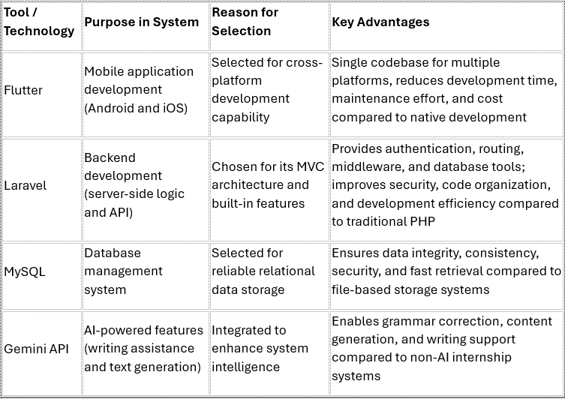
The development tools selected for the proposed system include Flutter, Laravel, MySQL, and the Gemini API, each serving a specific role in building a modern and efficient internship management platform. Flutter is used for mobile application development, enabling a single codebase for both Android and iOS, which improves development speed and reduces cost. Laravel is used for backend development due to its structured MVC architecture and built-in features that enhance security, maintainability, and development efficiency. MySQL is selected as the database system for its reliability, strong data integrity, and efficient data management capabilities. Lastly, the Gemini API is integrated to provide artificial intelligence features such as writing assistance, grammar improvement, and content generation, enhancing the overall functionality of the system.
Overall, the combination of these technologies ensures that the system is scalable, efficient, and capable of supporting both standard internship management functions and intelligent AI-assisted features.

Related Works and Similar Applications

A Digital Solution for Student Internship Tracking and Enhancing Student's Experience
Ahmed et al. (2026) proposed a digital internship tracking system to improve internship monitoring and communication between students and supervisors. The study was motivated by challenges associated with traditional internship management practices, including inefficient communication, difficulties in monitoring student progress, and the lack of centralized internship documentation. To address these issues, the researchers developed a digital platform that enables students to record internship activities, submit reports, and communicate with supervisors through a centralized system.
The study found that the proposed system improved internship monitoring, communication efficiency, and student engagement throughout internship activities. By digitizing internship documentation, the platform enhanced accessibility and reduced reliance on manual processes. However, the system primarily focused on activity tracking and internship management functions without integrating advanced intelligent features such as AI-assisted writing, automated reminder notifications, and image-based documentation support. These limitations provide opportunities for future improvements and highlight the need for more comprehensive internship management solutions.
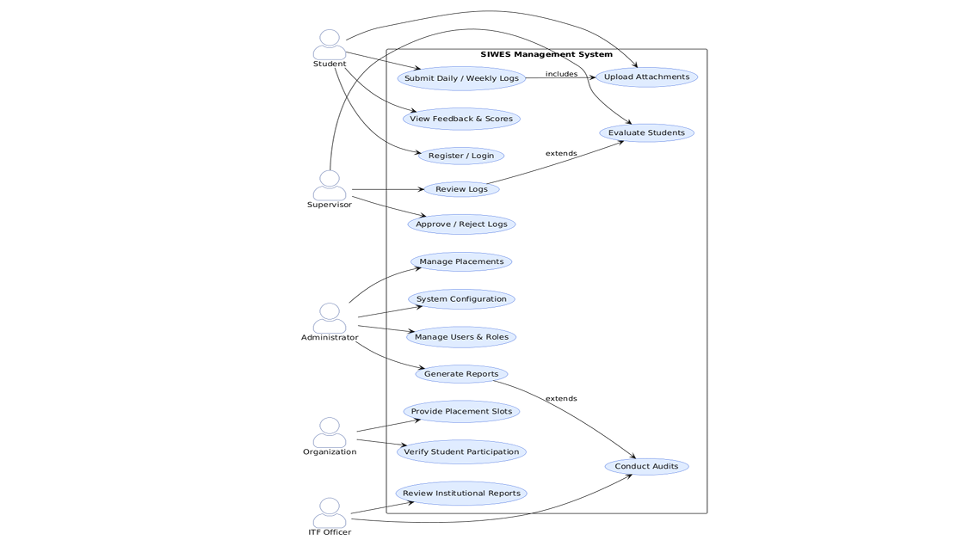 x
Figure 1. Proposed Student Internship Tracking Management System
(Source: Adapted from Ahmed et al. (2026))

The Development of an Integrated Cloud-Based System to Enhance Internship Management
Wan Abdul Rahman et al. (2024) developed E-Kehadiran, an integrated cloud-based internship management system designed to improve the efficiency and accuracy of attendance tracking and logbook submissions during internship programmes. The study was motivated by challenges in monitoring intern attendance, maintaining accurate records, and ensuring effective communication between universities, supervisors, and students. To address these issues, the researchers developed a web-based platform that provides functionalities such as user registration, attendance management, logbook submission, and performance monitoring through a centralized system.
The implementation results indicated that the system improved administrative efficiency, record management, and internship monitoring while facilitating better communication and collaboration among stakeholders. User acceptance testing also showed positive feedback regarding system integration, usability, and effectiveness in managing internship processes. However, the system primarily focuses on attendance management and logbook handling and does not provide intelligent features such as AI-assisted writing, automated feedback, or advanced documentation support. The authors suggested future enhancements including GPS-enabled attendance verification and notification features to remind interns to record attendance activities.
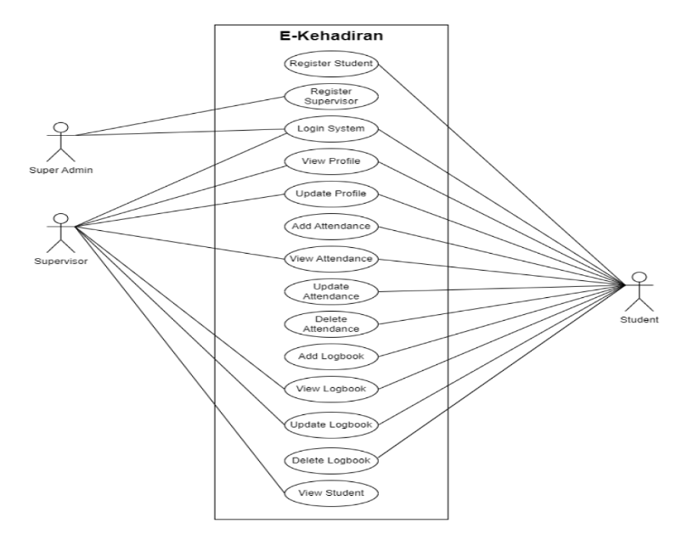
Figure 2. Use case diagram of the E-Kehadiran system
(Source: Wan Abdul Rahman et al. (2024))

Mobile-Based Student Internship Monitoring System Using Progress Tracking Algorithm
Castro (2024) developed a Mobile-based Student Internship Monitoring System using a Progress Tracking Algorithm to improve the management and monitoring of student internships. The study addressed challenges associated with manual internship monitoring, such as inaccurate attendance tracking, difficulties in verifying student locations, and inefficient record management. The system was developed as an Android-based application that digitizes the student internship handbook and enables various stakeholders, including students, faculty members, parents, partner agencies, and administrators, to access and manage internship-related information. To ensure accurate attendance monitoring, the system incorporates a GPS locator that verifies students' locations during clock-in and clock-out activities. The development process employed the Throw-Away Prototyping methodology and utilized Unified Modeling Language (UML) diagrams to design the system architecture.
The developed system was evaluated by 30 respondents consisting of student interns, faculty members, parents, partner agencies, and IT experts using the ISO 25010 software quality model. The evaluation results showed excellent ratings in functional suitability, reliability, performance efficiency, usability, security, compatibility, maintainability, and portability, indicating that the system effectively enhanced internship monitoring and administrative efficiency. Furthermore, the system successfully generated reports such as Daily Time Records (DTR) and daily task summaries, providing valuable insights into student internship activities. However, the study mainly focused on attendance verification, activity tracking, and internship record management. It did not include advanced features such as AI-assisted logbook writing, automated documentation generation, or analytics dashboards. Therefore, future internship management systems could be enhanced by integrating artificial intelligence technologies to support documentation, reporting, and performance analysis.

Web-Based Student Internship Monitoring Information System
Dewi and Hanifah (2024) developed a Web-Based Student Internship Monitoring Information System for SMK Ma'arif NU 2 Boyolali to address issues associated with manual internship monitoring processes. The existing system relied on paper-based journals, attendance sheets, daily activity records, final report submissions, and communication through WhatsApp, which resulted in inefficient data management and supervision. To overcome these challenges, the researchers developed a centralized web-based platform using the System Development Life Cycle (SDLC) methodology. The system provided three user roles: administrators, students, and field supervisors. Students could record attendance, submit daily logbooks, and upload internship reports, while supervisors could verify submissions and monitor student activities through the system.
The developed system was evaluated through Black Box Testing and user acceptance testing involving administrators, supervisors, and students. The results showed that all system functions operated successfully, and the overall user satisfaction score reached 87.53%, indicating that the system effectively improved internship monitoring, documentation management, and supervisory processes. However, the platform was primarily focused on administrative and monitoring functions through a web interface. It lacked mobile accessibility, real-time tracking capabilities, cloud synchronization, and intelligent automation features such as AI-assisted documentation and analytics. Therefore, future developments could integrate mobile applications, artificial intelligence technologies, and advanced reporting tools to further enhance internship management and user experience.
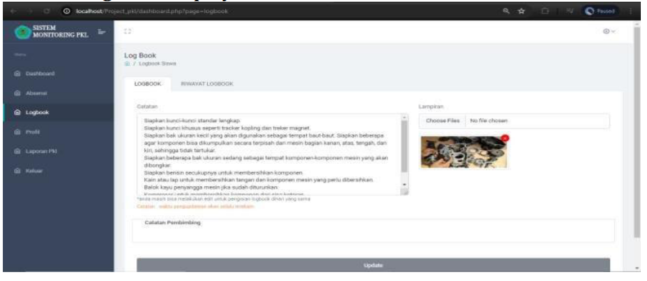
Figure 3. Student Logbook Menu Page
(Source: Dewi and Hanifah (2024))

Comparison of Existing Systems
Several internship management systems discussed in Sections 2.4.1 to 2.4.4 demonstrate different approaches to improving internship monitoring, documentation, and communication. While each system offers valuable features, they differ in terms of functionality, accessibility, and level of technological advancement.
Table 2.1 presents a comparison between the systems developed by Ahmed et al. (2026), Wan Abdul Rahman et al. (2024), Castro (2024), Dewi and Hanifah (2024), and the proposed E-Logbook Mobile Application.
Features | Ahmed et al. (2026) | Wan Abdul Rahman et al. (2024) | Castro (2024) | Dewi & Hanifah (2024) | Proposed System
Digital Logbook | ✓ | ✓ | ✓ | ✓ | ✓
Mobile Application | ✓ | ✗ | ✓ | ✗ | ✓
Web-Based System | ✓ | ✓ | ✗ | ✓ | ✓
Activity Recording | ✓ | ✓ | ✓ | ✓ | ✓
Real-Time Monitoring | ✓ | ✓ | ✓ | Limited | ✓
Attendance Tracking | Limited | ✓ | ✓ (GPS-based) | ✓ | ✓
Communication Features | ✓ | ✓ | Limited | Limited | ✓
Cloud-Based Storage | ✓ | ✓ | ✓ | Limited | ✓
AI-Assisted Writing | ✗ | ✗ | ✗ | ✗ | ✓
Reminder Notifications | ✗ | ✗ | ✗ | ✗ | ✓
Image Documentation | ✗ | ✗ | ✗ | ✗ | ✓
Intelligent Feedback | ✗ | ✗ | ✗ | ✗ | ✓
Based on the comparison, all existing systems provide core functionalities such as digital logbooks, activity recording, and internship monitoring. Ahmed et al. (2026) and Wan Abdul Rahman et al. (2024) emphasize centralized platforms and communication, Castro (2024) focuses on mobile accessibility and GPS-based tracking, while Dewi and Hanifah (2024) highlight web-based monitoring and structured supervision.
However, these systems mainly focus on administrative functions and lack advanced intelligent features such as AI-assisted writing, automated reminders, image documentation, and intelligent feedback. Therefore, the proposed E-Logbook Mobile Application addresses these gaps by integrating intelligent technologies with traditional functions, providing a more comprehensive and efficient solution for internship management.

Title | Author, Year | Issues | Methods | Result | Limitation | Future Work
A Digital Solution for Student Internship Tracking and Enhancing Student’s Experience | Ahmed et al., 2026 | Traditional internship management lacks efficient communication, centralized monitoring, and intelligent assistance between students and supervisors. | Developed a digital internship tracking platform with activity recording, report submission, and centralized communication features. | Improved internship monitoring, communication efficiency, and student engagement through a centralized system. | Focused mainly on tracking and management without AI-assisted writing, automation, or advanced intelligent features. | Future research may include AI-assisted writing, automated reminders, and intelligent documentation support.
The Development of an Integrated Cloud-Based System to Enhance Internship Management | Wan Abdul Rahman et al., 2024 | Difficulty in tracking attendance, maintaining accurate records, and ensuring effective communication among stakeholders. | Developed a cloud-based system (E-Kehadiran) with attendance tracking, logbook submission, and centralized monitoring. | Improved administrative efficiency, data accessibility, and communication between students, supervisors, and institutions. | Lacked intelligent features such as AI-assisted writing, automated feedback, and smart notification systems. | Future improvements may include GPS-based attendance, notification reminders, and intelligent feedback features.
Mobile-Based Student Internship Monitoring System Using Progress Tracking Algorithm | Castro, 2024 | Existing systems lack accurate attendance tracking, real-time monitoring, and efficient record management. | Developed a mobile-based internship system integrated with GPS tracking and progress tracking algorithms. | Improved attendance accuracy, real-time monitoring, and internship activity tracking efficiency. | Focused mainly on monitoring and tracking without AI-based documentation, analytics dashboards, or writing assistance. | Future work could integrate AI-assisted documentation, analytics dashboards, and enhanced reporting tools.
Web-Based Student Internship Monitoring Information System | Dewi & Hanifah, 2024 | Manual systems using paper-based records and messaging apps cause inefficient monitoring and data management. | Developed a web-based system using SDLC with features such as attendance, logbook submission, and supervisor verification. | Improved internship monitoring, documentation management, and achieved high user satisfaction. | Limited to web platform without mobile access, real-time tracking, cloud integration, or intelligent automation. | Future enhancements may include mobile applications, cloud integration, real-time tracking, and AI-based features.

Methodology
This chapter describes the structured approach and systematic development lifecycle adopted to design and develop the proposed Internship E-Logbook System. The Waterfall Model has been selected as the software development methodology to achieve the project objectives in an organised and efficient manner. The Waterfall Model follows a sequential, linear approach in which each phase, namely Requirement Analysis, System Design, Implementation, Testing, Deployment and Maintenance, must be fully completed before proceeding to the next. This methodology ensures clear documentation, strict control over project requirements, and structured milestones that directly support the development of the mobile application, web dashboard, database and AI-assisted features outlined in Chapters 1 and 2.

Project Framework (Software Development Methodology)
The Waterfall Model is selected as the software development methodology for the development of the Internship E-Logbook System, as it provides a sequential and well-documented process in which each phase, namely Requirement Analysis, System Design, Implementation, and Testing, is completed and reviewed before the next phase begins. This approach is considered appropriate for the present project because the functional and non-functional requirements of the system such as digital logbook entry, AI-assisted writing suggestions, reminder notifications, and supervisor monitoring were already identified through the background study and literature review in Chapters 1 and 2, reducing the likelihood of major changes once development is underway. Similar studies, such as Surahmat and Darmawan (2024), who applied the SDLC method together with the Laravel framework to develop a web-based information system, and Dewi and Hanifah (2024), who adopted the SDLC approach to develop a web-based internship monitoring system, reported that such structured, sequential methodologies resulted in systematic, well-documented, and easily implemented systems. The clear milestones and documentation produced at each stage of the Waterfall Model further allow the project supervisor to monitor and verify progress easily, making it a practical and manageable choice for a single-developer Final Year Project completed within a fixed academic timeframe.
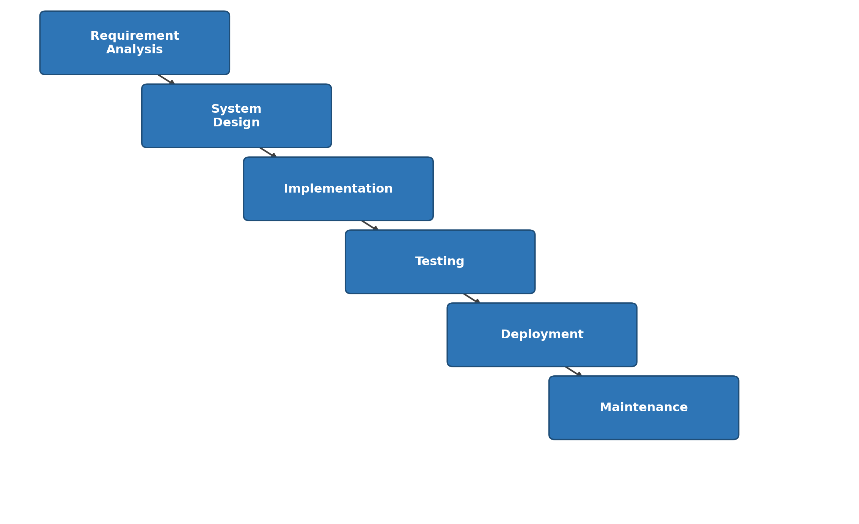
Figure 3.1: Waterfall Model Framework
As illustrated in Figure 3.1, the Waterfall Model adopted for this project consists of six sequential phases: Requirement Analysis, System Design, Implementation, Testing, Deployment, and Maintenance, with the output of each phase serving as the input to the next. Table 3.1 summarises all six phases of the model, together with their corresponding descriptions and key activities, to provide a clear overview of the methodology for verification purposes.
Table 3.1: Summary of the Waterfall Model Phases Applied in This Project
Waterfall Development Methodology

PHASE |  | ACTIVITIES |  | TECHNIQUE / TOOLS |  | DELIVERABLES
Phase 1:  Requirement  Analysis | → | - Identify user requirements  - Define functional requirements  - Define non-functional requirements  - Identify hardware and software needs | → | - Background study, literature review  - Laptop, smartphone  - Flutter SDK, Laravel  - PostgreSQL (Neon), Gemini API | → | - Requirements specification document  - Hardware and software requirements list
↓
Phase 2:  System  Design | → | - Design system architecture  - Draw system flowchart  - Design use case diagram  - Design ERD and database  - Design UI storyboard | → | - UML diagrams  - Figma / draw.io  - ERD design tool | → | - System architecture diagram  - Flowchart and use case diagram  - ERD and UI wireframes
↓
Phase 3:  Implementation | → | - Develop mobile app using Flutter  - Develop web dashboard using Laravel  - Implement PostgreSQL database on Neon  - Integrate Gemini API  - Implement real-time chat using Pusher Channels  - Implement push notifications using Firebase Cloud Messaging  - Implement image storage using Cloudinary  - Implement authentication using Laravel Sanctum | → | - Flutter (Dart)  - Laravel, PHP, HTML, CSS, Bootstrap  - PostgreSQL (Neon)  - Gemini API  - Pusher Channels  - Firebase Cloud Messaging  - Cloudinary  - Laravel Sanctum  - VS Code | → | - Mobile application prototype  - Web dashboard prototype  - Configured PostgreSQL database  - Integrated AI writing module  - Real-time chat module  - Push notification module  - Image upload module
↓
Phase 4:  Testing | → | - Conduct black box testing  - Verify all modules against requirements  - Record test cases and results  - Fix identified issues | → | - Black box testing method  - Manual test execution  - Bug tracking | → | - Test case documentation  - Test results report  - Verified prototype
↓
Phase 5:  Deployment | → | - Host web dashboard on server  - Publish mobile application  - Configure production database  - Train end users | → | - Web hosting server  - Mobile publishing platform  - Database migration tools | → | - Live web dashboard  - Published mobile app  - User training guide
↓
Phase 6:  Maintenance | → | - Monitor system performance  - Fix reported bugs  - Update features based on feedback | → | - Performance monitoring tools  - Bug tracking tools  - User feedback collection | → | - Performance reports  - Bug fix updates  - Enhanced system features
↓
Objective will be achieved

Phase 1: Requirement Analysis
The Requirement Analysis phase began with a preliminary study to establish a clear understanding of the problem domain before any design or development work was carried out. This preliminary study was conducted through a background study and a structured literature review, as presented in Chapters 1 and 2, rather than through a survey, interview, or questionnaire, since the intended respondents (internship students, lecturers, and company supervisors) were not directly accessible within the project timeframe. The literature review examined five related internship management and monitoring systems (Ahmed et al., 2026; Wan Abdul Rahman et al., 2024; Castro, 2024; Dewi & Hanifah, 2024) to identify recurring weaknesses in existing solutions, namely the lack of mobile accessibility, real-time monitoring, AI-assisted writing support, and automated reminder mechanisms. These findings, together with the problem statement in Section 1.2, were used to derive the functional and non-functional requirements of the proposed system.
The functional requirements identified for the system include user authentication and role-based access control, digital logbook entry creation and submission, AI-assisted writing suggestions, image-based documentation upload, real-time chat messaging between students and supervisors, and push notification reminders. The non-functional requirements include data security through token-based authentication, system availability through cloud-hosted services, and acceptable response time for real-time features such as chat and notifications.
Based on these requirements, the hardware and software needed to develop the prototype were identified, as summarised in Tables 3.2 and 3.3.
Table 3.2: Hardware Requirements
Hardware | Specification | Purpose
Laptop | Windows 10/11, minimum 8 GB RAM, Intel Core i5 or equivalent | Used for coding, running emulators, and managing the backend server during development
Android smartphone | Android 8.0 or above | Used for testing the Flutter mobile application on a physical device
Internet connection | Minimum 10 Mbps | Required to access cloud-hosted services (Neon, Pusher, Cloudinary, Gemini API, Firebase) during development and testing
Table 3.3: Software Requirements
Software/Tool | Purpose
Flutter SDK and Dart | Development of the cross-platform mobile application
Visual Studio Code | Primary code editor for both the Flutter application and Laravel backend
Laravel Framework (PHP) | Development of the backend RESTful API and web-based administrative dashboard
PostgreSQL (hosted on Neon) | Storage and management of structured application data
Google AI Studio (Gemini 1.5 Flash) | Provision of AI-assisted writing suggestions within the logbook module
Pusher Channels | Real-time chat messaging between students, lecturers, and company supervisors
Firebase Cloud Messaging | Delivery of push notifications for reminders and chat alerts
Cloudinary | Storage and delivery of internship documentation images

Phase 2: System Design
The System Design phase translates the requirements identified in Phase 1 into a structured technical design, covering the overall process flow, system architecture, database structure, and user interface layout of the proposed system.

System Flowchart
The system flowchart illustrates the overall process flow of the Internship E-Logbook System, beginning from user login and role verification, followed by role-specific functions such as logbook entry creation, AI-assisted writing, supervisor review, chat communication, and notification delivery.
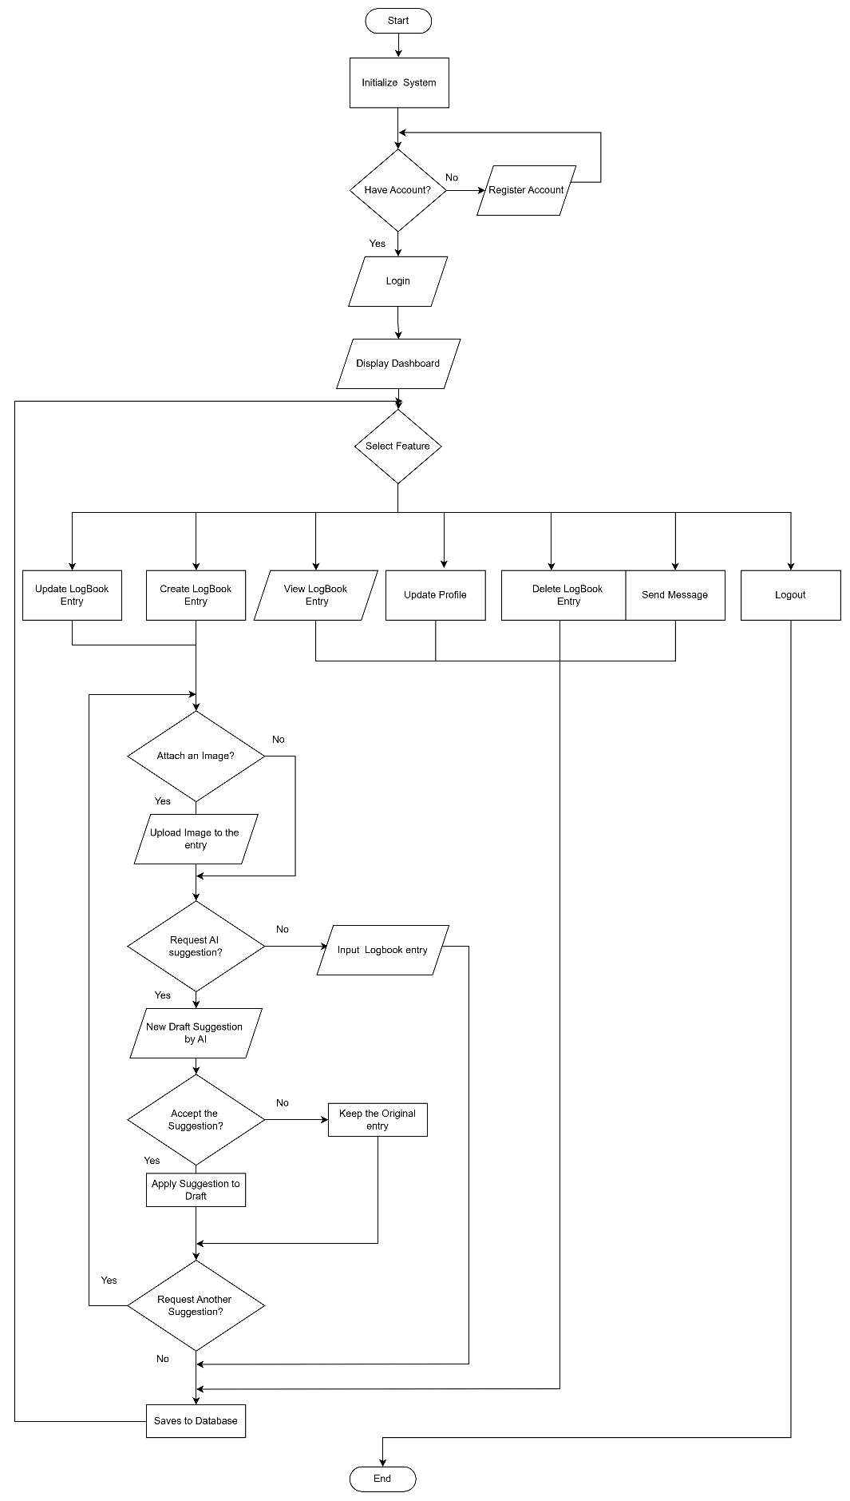
Figure 4. Student Flowchart
The flowchart illustrates the overall workflow of the proposed E-Logbook Mobile Application, beginning with system initialization and user authentication. After logging in, users are directed to the dashboard, where they can access various features such as creating, viewing, updating, or deleting logbook entries, managing their profile, sending messages, and logging out. When creating a logbook entry, users may upload supporting images and request AI-assisted writing suggestions to improve their content before deciding whether to accept or reject the generated text. Once the entry is completed, it is saved to the database, marking the end of the process. This flowchart provides a clear representation of the system's operational flow and user interactions.

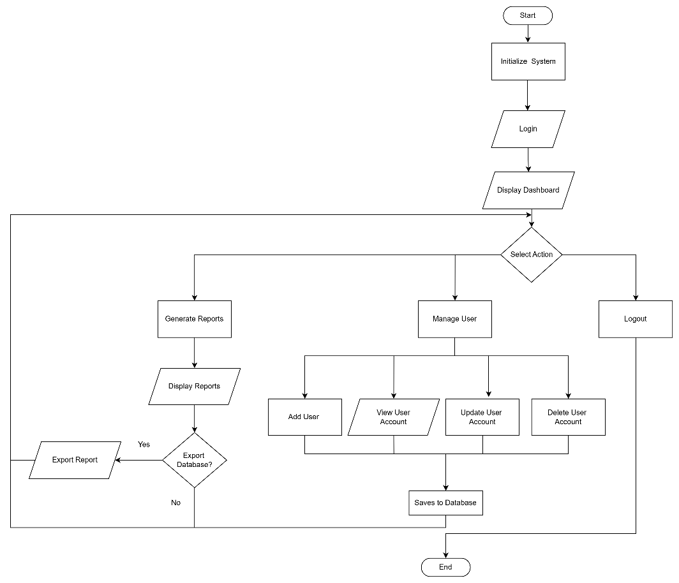
Figure 5. Admin Flowchart
The flowchart illustrates the overall workflow of the user management and reporting system. The process begins with system initialization, followed by user login and the display of the dashboard. After accessing the dashboard, the user selects an action, which includes managing users, generating reports, or logging out. Under the user management module, administrators can add, view, update, or delete user accounts, with any changes being saved to the database. In the reporting module, users can generate and display reports, with an option to export the database or reports when required. Once all operations are completed, the process ends, ensuring a structured and efficient workflow for system administration and report management.
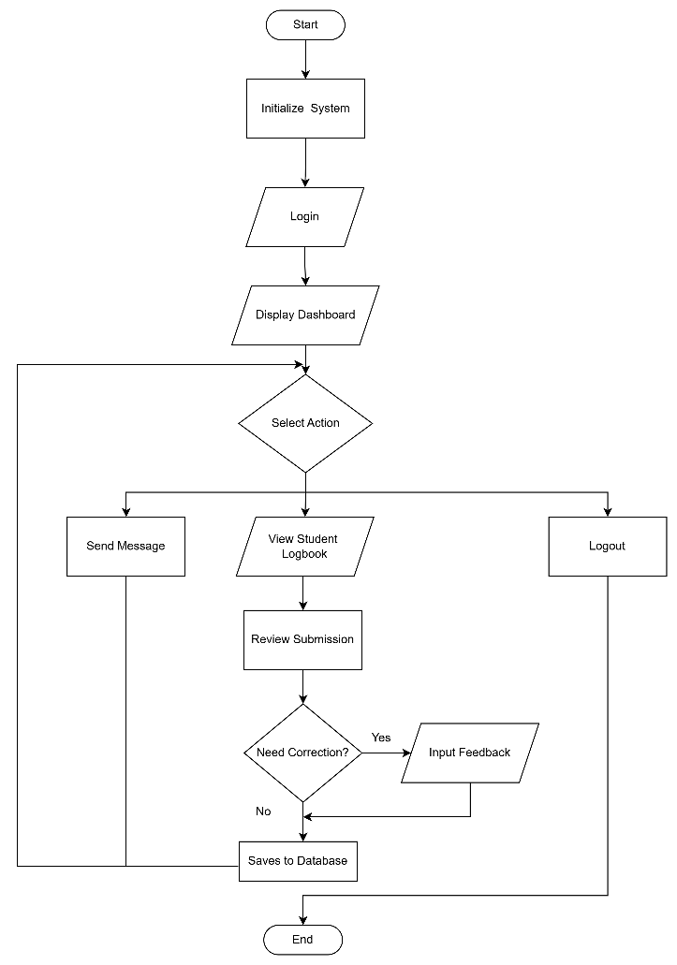
Figure 6. Lecturer and Company Supervisor Flowchart
The flowchart illustrates the workflow of the lecturer module in the student logbook management system. The process begins with system initialization, followed by user login and the display of the dashboard. After accessing the dashboard, the lecturer selects an action, which may include viewing student logbooks, sending messages, or logging out. When reviewing a student's logbook, the lecturer evaluates the submitted work and decides whether corrections are required. If revisions are needed, the lecturer inputs feedback for the student to improve the submission. All reviews and feedback are then saved to the database, ensuring that student records are updated and accessible for future reference. Once the selected tasks are completed, the workflow ends, providing an organized and efficient process for monitoring and evaluating student logbook submissions.

System Architecture
The proposed system adopts a three-tier architecture consisting of the presentation layer, application layer, and data layer, with integrated cloud services to support its core functionalities. As illustrated in Figure 7, the architecture defines how the Flutter mobile application and Laravel web dashboard communicate with the Laravel backend, which serves as the central component for processing business logic and managing data. The backend also integrates with external cloud services, including Neon PostgreSQL, Gemini API, Pusher Channels, Firebase Cloud Messaging (FCM), and Cloudinary, to provide database management, AI-assisted writing, real-time communication, push notifications, and media storage.
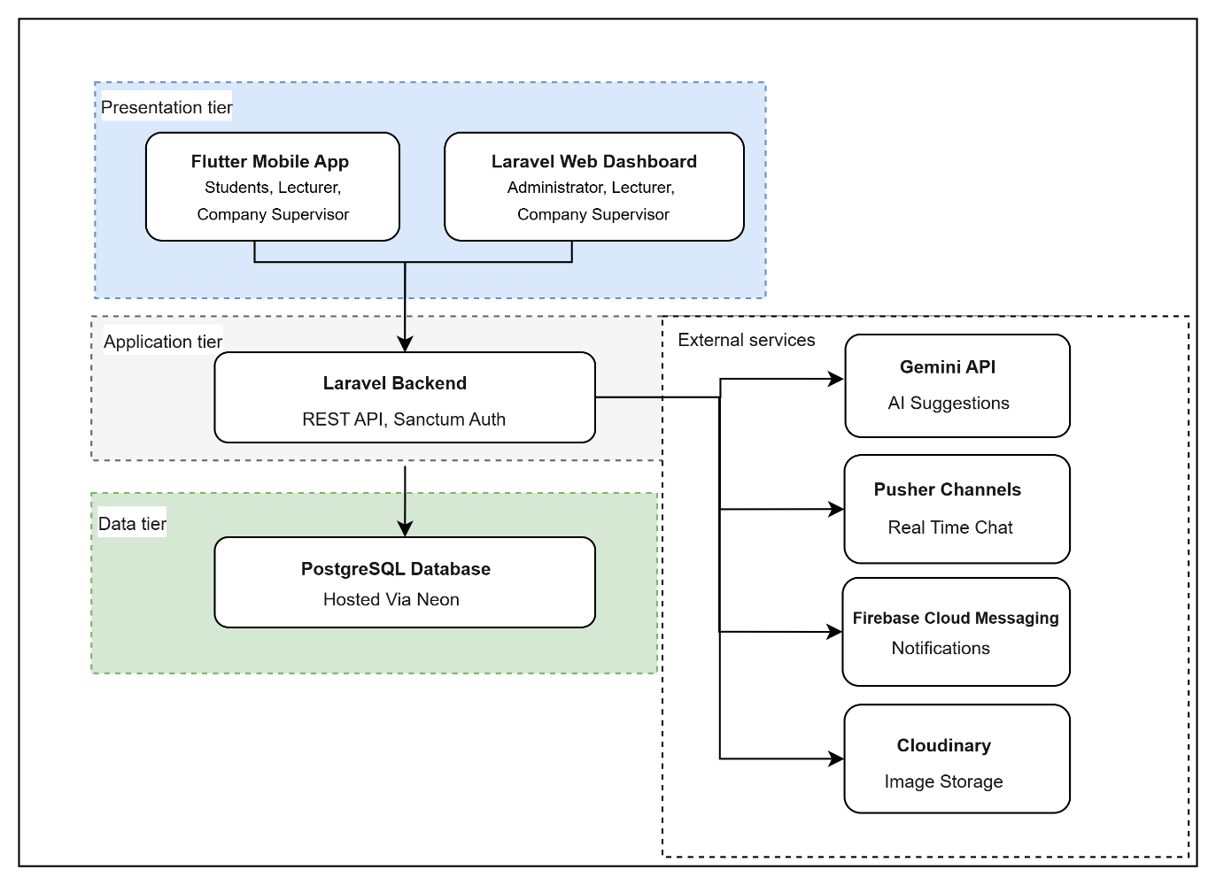
Figure 7. Three Layer System Architecture

The proposed system adopts a three-tier architecture consisting of the presentation layer, application layer, and data layer, with several external cloud services integrated to enhance functionality. At the presentation layer, users interact with the system through two different platforms based on their roles. The Flutter mobile application enables students, lecturers, and company supervisors to access internship-related features such as report submissions, progress tracking, messaging, and notifications using mobile devices. Meanwhile, the Laravel web dashboard provides administrators, lecturers, and company supervisors with a browser-based interface for managing users, reviewing reports, monitoring internship activities, and performing administrative tasks. Both applications communicate with the backend through secure RESTful API requests.
The Laravel backend serves as the core of the application layer by processing all incoming requests from both client applications. It implements the system's business logic, validates user input, manages authentication using Laravel Sanctum, and coordinates communication between the database and external cloud services. Instead of allowing the client applications to directly access third-party services, all requests are routed through the backend, providing an additional layer of security by protecting API credentials while ensuring consistent data validation and centralized system management. The backend also integrates with the Gemini API to provide AI-assisted writing suggestions, Pusher Channels to enable real-time messaging, Firebase Cloud Messaging (FCM) to deliver push notifications, and Cloudinary to manage image uploads and cloud-based media storage.
The data layer consists of a PostgreSQL database hosted on Neon, which functions as the central repository for all application data, including user accounts, internship records, reports, attendance, chat messages, notifications, and other system information. By hosting the database on a cloud platform, the system benefits from improved scalability, reliability, and automated maintenance while ensuring secure data storage and accessibility. Overall, the layered architecture separates the user interface, application logic, and data management into independent components, making the system easier to maintain, more secure, and capable of supporting future enhancements while delivering a responsive experience across both mobile and web platforms.

Use Case Diagram
The use case diagram illustrates the functional requirements of the proposed E-Logbook Mobile Application with AI-Assisted Writing and Reminder System by identifying the interactions between the system and its four primary actors: Student, Lecturer, Company Supervisor, and Administrator. Each actor is assigned specific responsibilities and system functionalities according to their respective roles, ensuring that users can only access features relevant to their permissions.
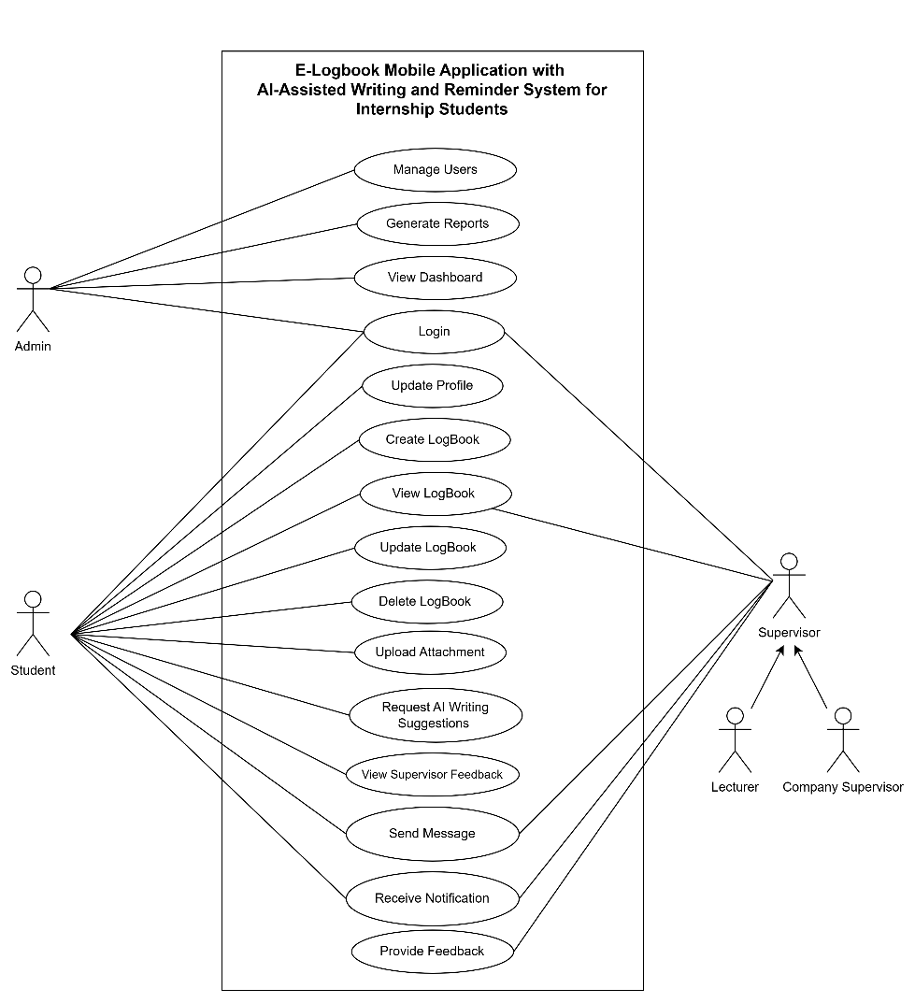
Figure 8. System Use Case Diagram

Students are the primary users of the system and can perform functions such as logging in, updating their profile, creating, viewing, updating, and deleting logbook entries, uploading supporting attachments, requesting AI-assisted writing suggestions, viewing supervisor feedback, sending messages, and receiving notifications. Lecturers and company supervisors are responsible for monitoring students' internship progress by reviewing logbook submissions, providing feedback, communicating with students through the messaging feature, and receiving notifications regarding internship activities. The administrator is responsible for managing user accounts, monitoring system activities through the dashboard, generating reports, and maintaining the overall operation of the system.
Overall, the use case diagram provides a high-level representation of the system's functional behaviour by defining the interactions between users and the system. It serves as a blueprint for the system requirements, ensuring that each stakeholder's responsibilities and accessible functions are clearly defined while supporting secure role-based access control throughout the application.

Entity-Relationship Diagram (ERD)
The ERD represents the database structure of the system, showing the key entities and their relationships, including Users, Roles, Logbook Entries, Comments, Attachments, Chat Messages, and Notifications. Each logbook entry is linked to a single student and may contain multiple attachments and comments, while users are assigned roles that determine their level of access within the system.
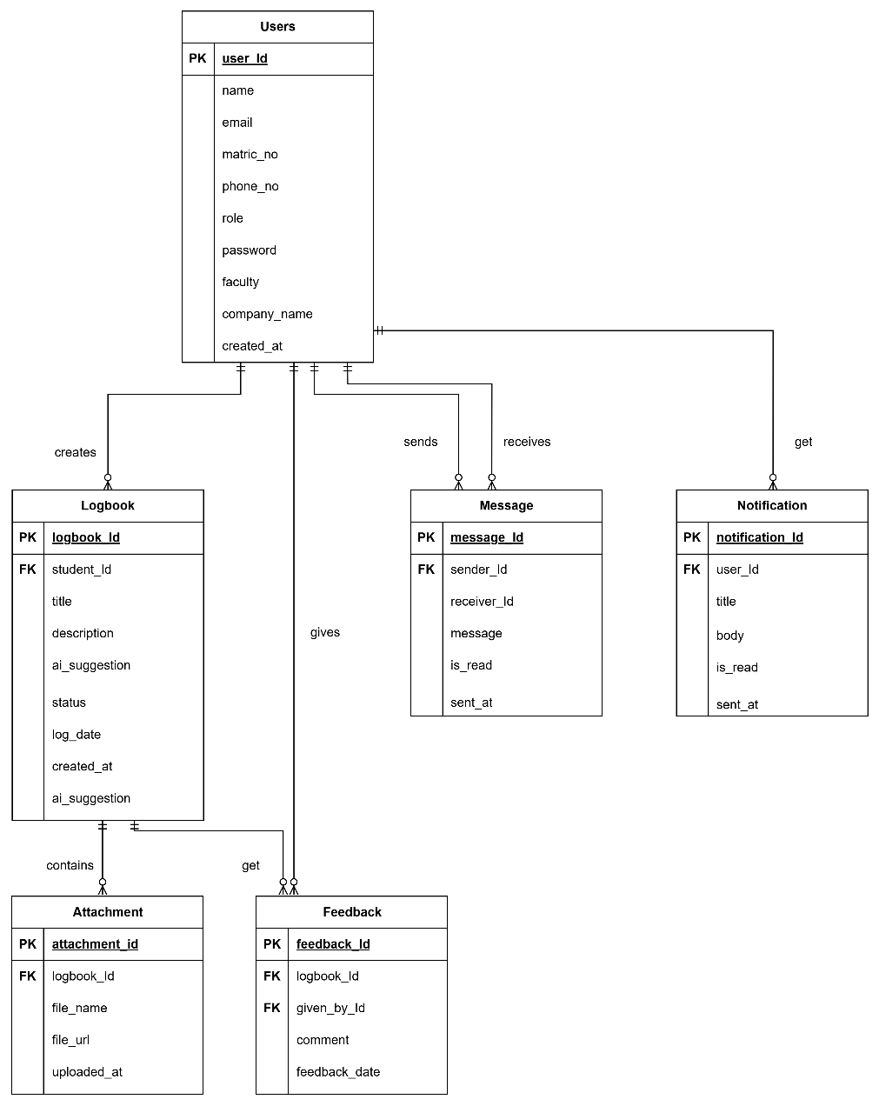
Figure 9. System ERD
The Users entity stores the information of all system users, including students, lecturers, company supervisors, and administrators. It contains user profile details, authentication credentials, and role information required to manage system access and permissions.
The Logbook entity records students' internship activities and daily progress throughout the internship period. Each logbook entry is associated with a specific student and serves as the primary record for monitoring internship performance.
The Message entity manages communication between students, lecturers, and company supervisors. It stores chat messages exchanged within the system, enabling real-time discussion and collaboration during the internship.
The Notification entity stores system-generated notifications sent to users. These notifications inform users about important events such as new messages, feedback, reminders, logbook updates, and other internship-related activities.
The Attachment entity stores references to files uploaded by students as supporting evidence for their logbook entries. These files may include images, documents, or other relevant materials and are linked to the corresponding logbook record.
The Feedback entity records comments and evaluations provided by lecturers or company supervisors on students' logbook submissions. It enables supervisors to review student progress, provide constructive feedback, and monitor internship performance effectively.

Storyboard and User Interface Design
The storyboard illustrates the sequence of screens and interactions that users follow when performing the system's core functions. It provides a visual representation of the user journey, beginning with the login page and continuing through key features such as the dashboard, logbook management, AI-assisted writing suggestions, attachment uploads, real-time messaging, notifications, and profile management. By mapping the navigation flow between these screens, the storyboard ensures that the proposed user interface is intuitive, consistent, and user-friendly, allowing users to complete their internship-related tasks efficiently while maintaining a seamless experience throughout the application.

.
Storyboard | Description
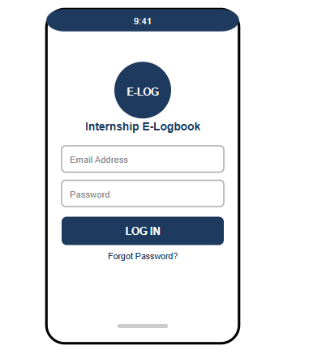  Figure 10. Login Page | This page allows users to log in using their registered email address and password. After successful authentication, users are redirected to their respective dashboard based on their assigned role.
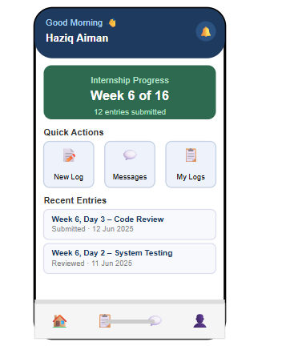  Figure 11. Student Dashboard | This page provides students with an overview of their internship progress and quick access to key features such as creating logbook entries, viewing logbooks, and accessing the messaging interface.
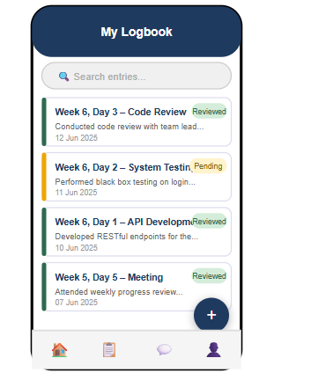  Figure 12. Logbook List Page | This page displays all logbook entries submitted by the student. Users can search for specific entries, view their submission status, and create new logbook entries.
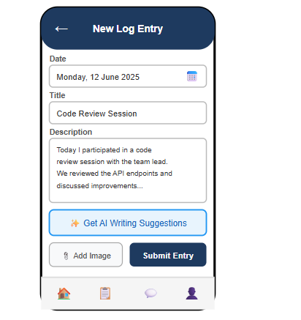  Figure 13. Create Logbook Entry Page | This page enables students to create and submit new logbook entries by entering internship activities, attaching supporting images, and requesting AI-assisted writing suggestions before submission.
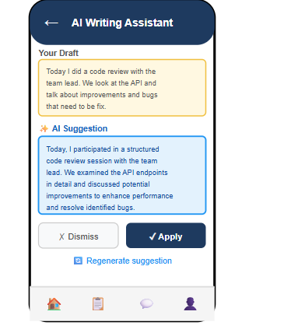  Figure 14. AI Writing Assistance Page | This page displays AI-generated writing suggestions to help students improve their logbook content. Students may apply, discard, or regenerate the suggested text.
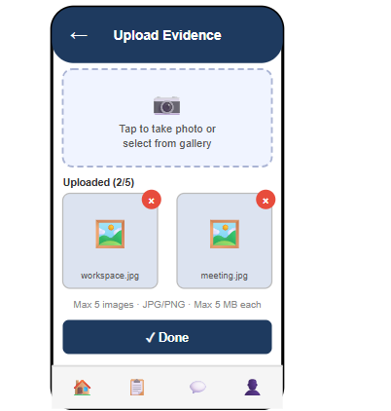  Figure 15. Attachment Upload Page | This page allows students to upload supporting images for their logbook entries by capturing a photo or selecting one from the device gallery before submission.
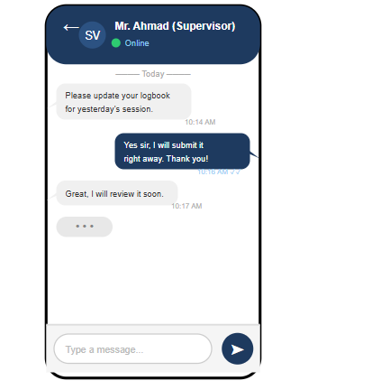  Figure 16. Messaging Page | This page enables real-time communication between students, lecturers, and company supervisors, allowing users to exchange messages and receive updates during the internship.
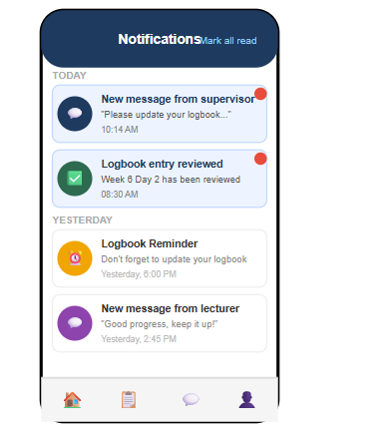  Figure 17. Notification Page | This page displays system notifications, including reminders, logbook updates, feedback, and new messages, ensuring users remain informed of important activities.
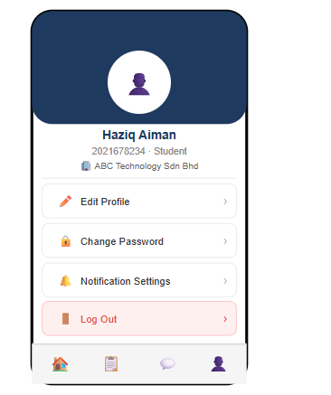  Figure 18. Profile Page | This page displays the user's personal information and account settings. Users can update their profile, change their password, manage notification preferences, and log out of the application.

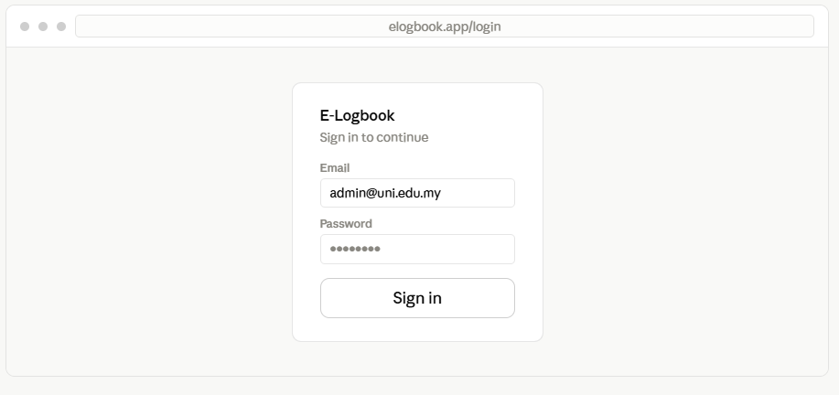
Figure 19. Webpage Login page
Entry point for admins and supervisors. Users enter their registered email and password. Laravel Sanctum verifies credentials and redirects each role to the appropriate dashboard view.
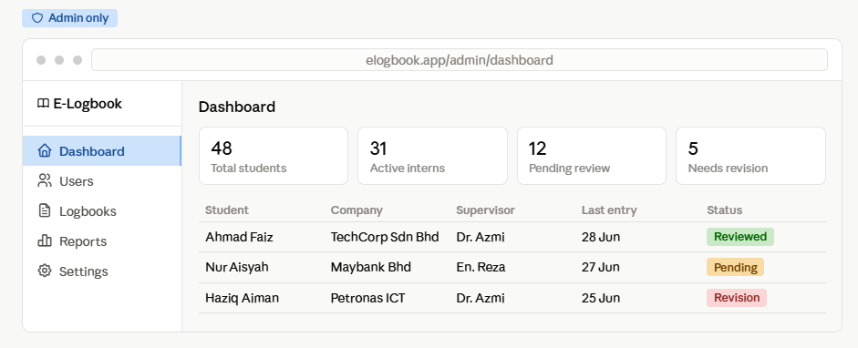
Figure 20. Admin Dashboard
This page provides administrators with an overview of the system, including internship statistics, user information, and pending logbook submissions. It also offers quick access to user management and report generation features.
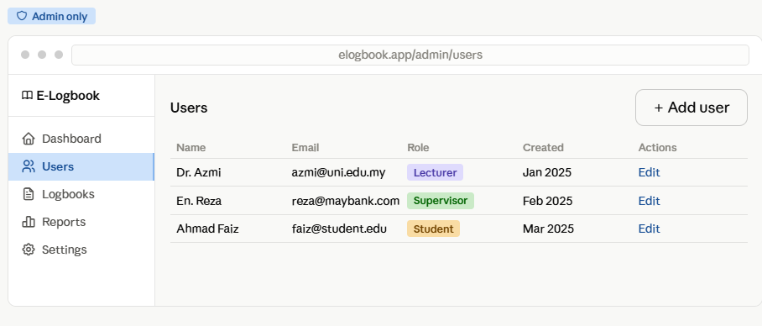
Figure 21. Admin User Management
This page allows administrators to manage all user accounts, including students, lecturers, and company supervisors. Administrators can create, edit, delete user accounts, and assign roles to control access permissions within the system.
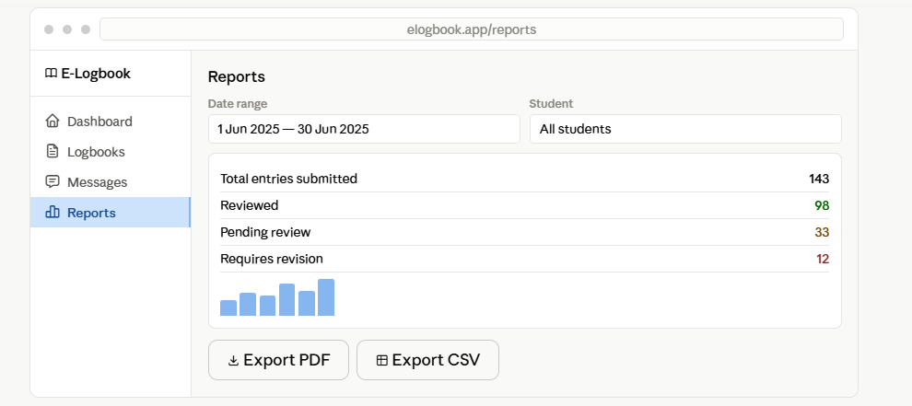
Figure 22. Generate and Download Reports
Admins can generate system-wide reports across all students. Lecturers and supervisors generate reports scoped to their own assigned students only.
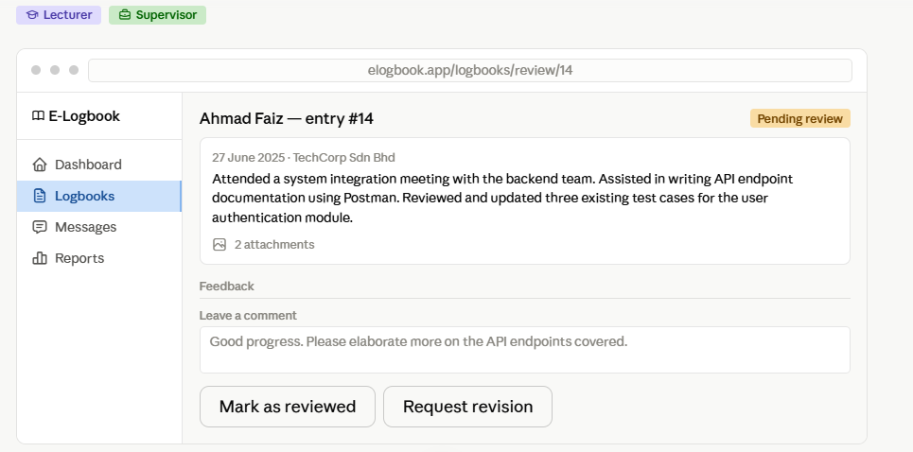
Figure 23. Logbook Review
View student entries and provide feedback. Lecturers and company supervisors see their assigned students' logbook entries in detail. They can mark entries as reviewed, request revision, or leave written feedback.

Phase 3: Implementation
The Implementation phase involved translating the design produced in Phase 2 into a working prototype. Development followed the modules identified in the system flowchart, with each module implemented using the tools and technologies justified in Section 2.6.

Authentication and Role-Based Access Control Module
This module was implemented using Laravel Sanctum for token-based authentication and the Spatie Laravel Permission package for role-based access control. Upon login, the Laravel backend verifies the user's credentials against the PostgreSQL database and issues a personal access token, which is stored securely on the mobile device using the flutter_secure_storage package and attached to all subsequent API requests. The user's assigned role, Student, Lecturer, Company Supervisor, or Administrator, determines not only the data and actions accessible within the application, but also which client surface the user is expected to use: Students access the system exclusively through the Flutter mobile application, Lecturer and Company Supervisor accounts are granted access to both the mobile application and the web dashboard, and Administrator accounts are restricted to the web dashboard.

Logbook Module
The logbook module allows students to create and edit logbook entries through a single composition interface, rather than as separate standalone actions. Within this interface, a student may write the entry text, optionally attach a supporting image, and optionally request an AI-generated writing suggestion before saving the entry, as detailed in Section 1.1.3. This module was developed using Flutter for the front-end form interface and Laravel for the backend API, with entries stored in the PostgreSQL database via the Eloquent ORM (Surahmat & Darmawan, 2024; Akhtar, 2023). Lecturers and company supervisors can view submitted entries either through the Flutter mobile application, for quick checks while away from a desk, or through the web dashboard, where entries are presented alongside the review and feedback tools described in Section 1.1.7.

AI-Assisted Writing Module
This module integrates the Gemini 1.5 Flash model through the Laravel backend controller, ensuring that the API key is never exposed to the mobile client. Gemini 1.5 Flash was selected in part because it accepts text and image inputs within the same request, a capability of the underlying Gemini 1.5 model family that allows reasoning across combined modalities rather than text alone (Gemini Team, 2024). This allows the AI-assisted writing feature to generate suggestions in two ways: when a student requests a suggestion based on the draft text alone, only the text is forwarded to the Gemini API; when a student has attached an image to the entry and chooses to include it, the image is forwarded alongside the text in a single multimodal request, allowing the model to generate suggestions that reference the content of the image, for example describing an activity shown in a photograph as part of the suggested entry text. The generated suggestion is returned to the mobile application, where the student may accept it, apply it to replace or extend the original draft, keep the original draft unchanged, or request a further suggestion, consistent with established findings that AI-assisted writing tools are most effective when the writer retains control over whether to accept generated suggestions (Lang et al., 2024).

Real-Time Chat Module
The chat module was implemented using Pusher Channels integrated with Laravel Broadcasting and Laravel Echo on the backend, and the pusher_channels_flutter package on the mobile application. Messages sent by students, lecturers, or company supervisors are broadcast instantly to the relevant channel, allowing all participants to communicate without manual page refreshes. This module is available only on the Flutter mobile application; the web dashboard does not provide chat functionality, since real-time messaging is intended for use while students and supervisors are away from a desk, which the mobile application already supports without requiring a separate browser-based integration.

Notification Module
Push notifications for logbook reminders, new chat messages, and feedback updates were implemented using Firebase Cloud Messaging. The Laravel backend sends notification payloads through the FCM HTTP v1 API, while the Flutter application receives and displays these notifications using the firebase_messaging package. As with the chat module, push notifications are scoped to the mobile application only.

Image Documentation Module
This module enables students to attach supporting images to a logbook entry as evidence of internship activities, as part of the composition workflow described in Section 1.1.2. Uploaded files are handled by the Laravel backend using the cloudinary-laravel SDK, which stores the images on Cloudinary and returns a CDN-backed URL. This URL is stored in the PostgreSQL database and used by the Flutter application to display the image via the Image.network() widget, and is also passed to the Gemini API when a student requests an image-based AI suggestion, as described in Section 1.1.3.

Web-Based Dashboard
In addition to the mobile application, a web-based dashboard was developed using Laravel and Laravel Blade (Surahmat & Darmawan, 2024). The dashboard serves two groups of users with distinct functions. Administrators use the dashboard to manage user accounts, monitor system-wide usage, and generate reports covering all students within the system. Lecturers and company supervisors use the same dashboard to review submitted logbook entries in detail, provide feedback, and generate reports scoped to their own assigned students only, distinguishing their reporting function from the system-wide reports available to Administrators.

Phase 4: Testing
The Testing phase was carried out to verify that each module of the prototype functioned according to its intended requirements. Functionality testing was selected as the testing method for this project, using the black box testing technique, in which the system is tested based on its expected input and output behaviour without examining the internal source code. This approach was considered the most suitable for this project, as the primary objective of testing was to confirm that each feature, such as login, logbook submission, AI-assisted suggestions, chat messaging, and notifications, performed correctly from the end user's perspective, rather than to measure algorithmic accuracy or processing efficiency.
Test cases were designed to cover the main functions of each module identified in Phase 3. Each test case specifies the module being tested, the test steps, the expected outcome, and the actual outcome, with a final status of "Pass" or "Fail" recorded. Table 3.4 presents a sample of the functionality test cases used to verify the system.
Table 3.4: Sample Functionality Test Cases
Test ID | Module | Test Description | Expected Result | Actual Result | Status
TC01 | Authentication | User logs in with valid credentials | User is authenticated and redirected to the dashboard | [To be recorded during testing] | [Pass/Fail]
TC02 | Authentication | User logs in with invalid credentials | System displays an error message and denies access | [To be recorded during testing] | [Pass/Fail]
TC03 | Logbook Module | Student submits a new logbook entry | Entry is saved successfully and appears in the logbook list | [To be recorded during testing] | [Pass/Fail]
TC04 | AI-Assisted Writing | Student requests writing suggestions for a draft entry | System returns relevant suggestions within an acceptable time | [To be recorded during testing] | [Pass/Fail]
TC05 | Chat Module | Student sends a message to a supervisor | Message appears instantly on the supervisor's chat interface | [To be recorded during testing] | [Pass/Fail]
TC06 | Notification Module | New chat message is sent to an offline user | User receives a push notification on their device | [To be recorded during testing] | [Pass/Fail]
TC07 | Image Documentation | Student uploads an image as supporting evidence | Image is uploaded successfully and displayed in the entry | [To be recorded during testing] | [Pass/Fail]
Any test case that returns a "Fail" status is documented along with the cause of failure, and the corresponding module is revised and retested until the expected result is achieved. This iterative process continues until all functional requirements identified in Phase 1 have been successfully verified.

REFERENCE
Ahmed, M. O., Neal, A. O., & Esther, C. C. (2026). A digital solution for student internship: Tracking and enhancing student's experience. Asian Journal of Basic Science & Research, 8(1), 23–36. https://doi.org/10.38177/ajbsr.2026.8103
Rahman, W. F. W. A. (2022). The development of an integrated cloud-based system to enhance internship management. Journal of ICT in Education, 9(2), 55–70. https://ejournal.upsi.edu.my/index.php/JICTIE/article/view/9878
Castro, E. G. M. (2024). Mobile-based student internship monitoring system using progress tracking algorithm. International Research Journal on Advanced Science Hub, 6(8), 204–209. https://doi.org/10.47392/IRJASH.2024.029
Dewi, F. K., & Hanifah, R. N. (2024). Web-based student internship monitoring information system (Case study: SMK Ma’arif NU 2 Boyolali). IC-ITECHS, 5(1), 943–956. https://jurnal.ubhinus.ac.id/index.php/IC-ITECHS/article/view/1705/978
Thammastitkul, A. (2022). Cloud-based Computing Adoption in Internship Management System for University Education. Asian Health, Science and Technology Reports, 31(1), 58–73. https://doi.org/10.14456/nujst.2023.7
Ahmed, M. O., Neal, A. O., & Chizoba, C. (2026). A digital solution for student internship: Tracking and enhancing student’s experience. Asian Journal of Basic Science & Research, 8(1), 23–36. https://doi.org/10.38177/ajbsr.2026.8103
Akhtar, A. (2023). Popularity ranking of database management systems. arXiv. https://arxiv.org/abs/2301.00847
Castro, E. G. M. (2024). Mobile-based student internship monitoring system using progress tracking algorithm. International Research Journal on Advanced Science Hub, 6(8), 204–209. https://doi.org/10.47392/IRJASH.2024.029
Chen, W. (2024). Construction of student information management system for universities based on cloud computing platform. Applied Mathematics and Nonlinear Sciences, 9(1). https://doi.org/10.2478/amns.2023.2.00766
Dewi, F. K., & Hanifah, R. N. (2024). Web-based student internship monitoring information system (Case study: SMK Ma’arif NU 2 Boyolali). IC-ITECHS, 5(1), 943–956. https://doi.org/10.32664/ic-itechs.v5i1.1705
Husin, M. Z., Ganes, P. R., & Puteh, N. (2024). A web-based industrial training management system: A case study of the School of Computing. Journal of Digital System Development, 2(2), 64–78. https://doi.org/10.32890/jdsd2024.2.2.5
Kambaruddin, M. S. B., Wan Yusuf, W. A. R. B., & Yaakob, M. A. B. (2024). An improved flashcard-based ICS mobile application for effective teaching and learning of DFC10033 – Introduction to Computer System. International Journal of Software Engineering and Computer Systems, 10(2), 103–118. https://doi.org/10.15282/ijsecs.10.2.2024.9.0127
Setiaji, P., Adiyono, S., Prayogo, A., & Kurniasari, N. (2025). Developing a cloud-native internship management platform: Enhanced efficiency and integration through object-oriented architecture. Journal of Information Systems and Informatics, 7(1), 631–648. https://doi.org/10.51519/journalisi.v7i1.1036
Lang, G., Triantoro, T., & Sharp, J. H. (2024). Large language models as AI-powered educational assistants: Comparing GPT-4 and Gemini for writing teaching cases. Journal of Information Systems Education, 35(3), 390–407. https://doi.org/10.62273/YCIJ6454
Sumarto, M. A. (2023). Analisis dan perancangan aplikasi point of sale berbasis mobile menggunakan framework Flutter dengan metode rapid application development (RAD). Jurnal Studi Komunikasi dan Media. https://doi.org/10.17933/jskm.2023.5115
Surahmat, A., & Darmawan, R. (2024). Application of the SDLC method and Laravel framework in developing a web draft-based company profile information system. Scientific Journal of Information System, 2(1), 20–25. https://doi.org/10.70429/sjis.v2i1.101
Thammastitkul, A. (2023). Cloud-based computing adoption in internship management system for university education. Naresuan University Journal: Science and Technology, 31(1), 58–73.
Wan Abdul Rahman, W. F., Mohamad Bustamam, M. S., & Putra, Y. H. (2024). The development of an integrated cloud-based system to enhance internship management. Journal of ICT in Education, 11(2), 92–110. https://doi.org/10.37134/jictie.vol11.2.8.2024
Wang, C., & Wang, D. (2023). Managing the integration of teaching resources for college physical education using intelligent edge-cloud computing. Journal of Cloud Computing: Advances, Systems and Applications, 12(82), 1–14. https://doi.org/10.1186/s13677-023-00455-1
Xue, S., Wang, C., & Muhaimaiti, M. (2023). Examining the affordances of an online learning platform: A usefulness theoretical perspective. SAGE Open, 13(4). https://doi.org/10.1177/21582440231202821

